**Docker Networking**

The Docker network is a virtual network created by Docker to enable communication between [Docker containers](https://www.geeksforgeeks.org/containerization-using-docker/). If two containers are running on the same host they can communicate with each other without the need for ports to be exposed to the host machine.

### **Types of Docker Networks**

* **Bridge (default):**If you build a container without specifying the kind of driver, the container will only be created in the bridge network, which is the default network.
* **Host:**Containers will not have any IP address they will be directly created in the system network which will remove isolation between the docker host and containers.
* **None/null:**IP addresses won’t be assigned to containers. These containments are not accessible to us from the outside or from any other container.

**Steps:**

**Create and EC2 instance and deploy Docker.**

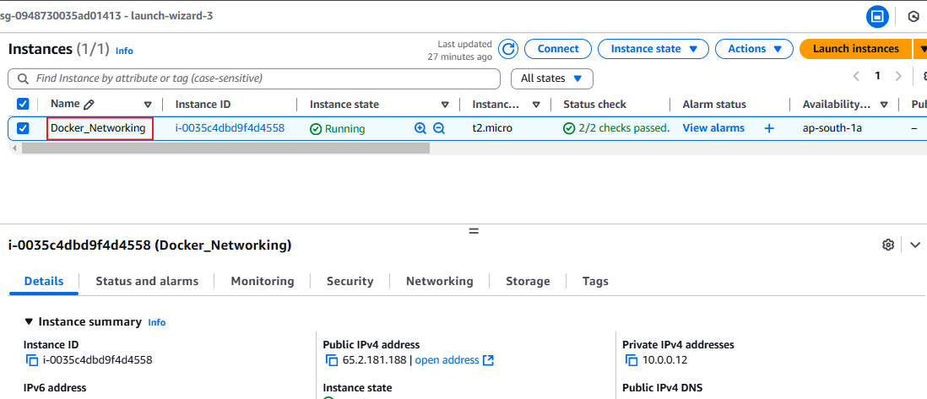

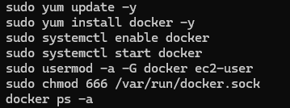

**Pull images from Docker hub,**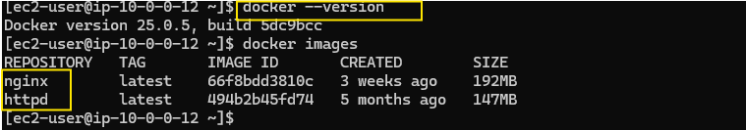

**Create a Bridge network,**

Bridge networks apply to containers running on the same Docker daemon host.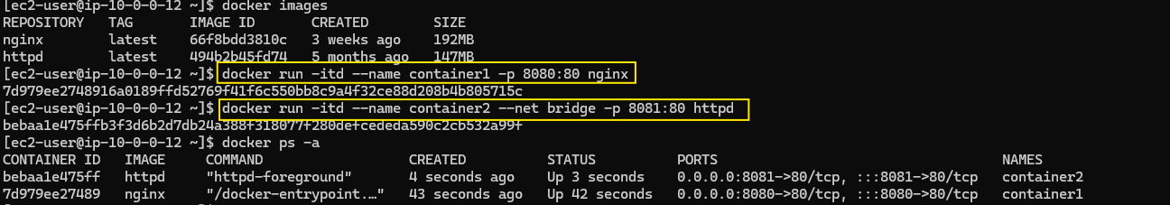

Inspect network: Display detailed information on one or more networks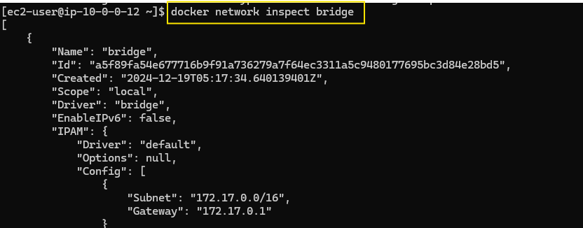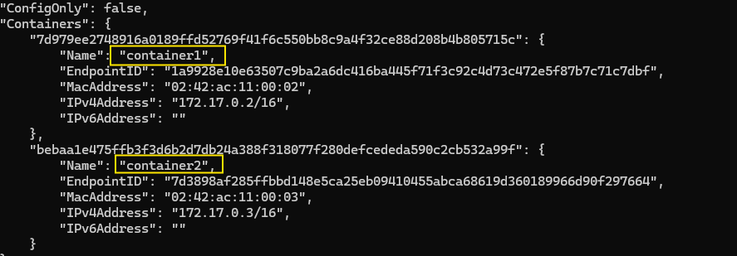

Allow port 8080 and 8081 in the inbound rule at the security group of the EC2 instance.

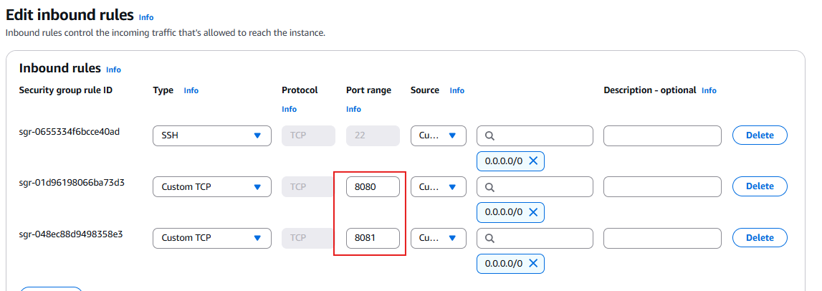

Containers on the same bridge network can communicate directly using their container names as hostnames.

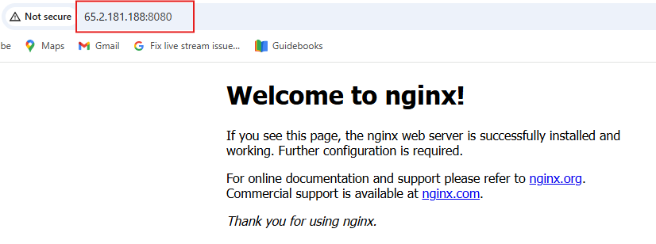

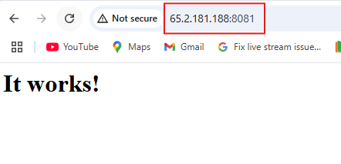

**Creating Host Network,**

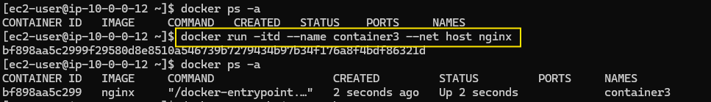

Inspecting host Network,

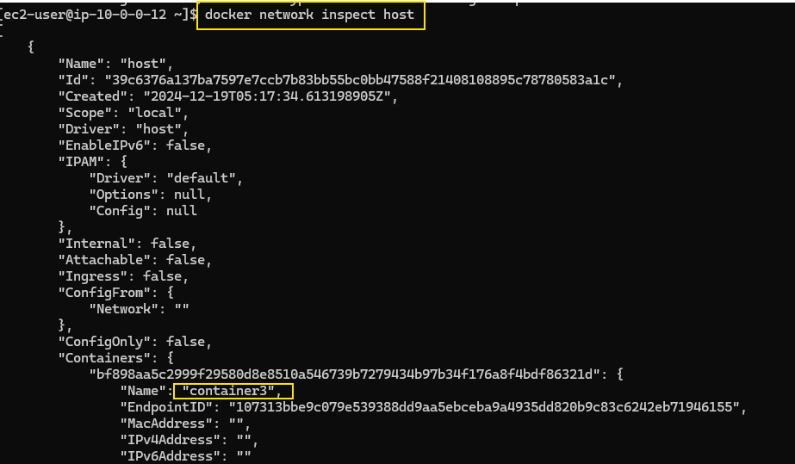

Edit the inbound rule to allow All Traffic,

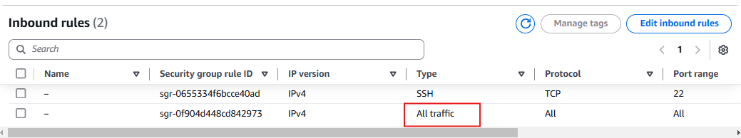

The container has direct access to the host's network interface,

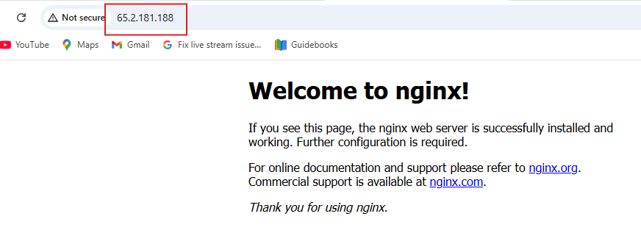

**Creating a none network,**

The container has no external or internal network connectivity.

